**2. Hands-on exercise – camera calibration**

1. loading images

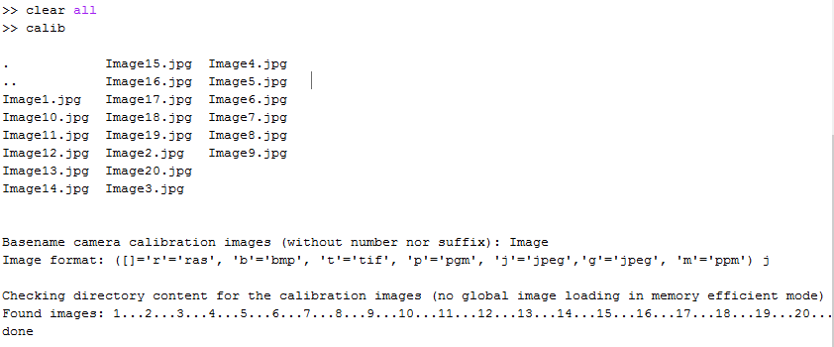

2. mosaic view of the images



3. Extracting grid corners



4. Main calibration

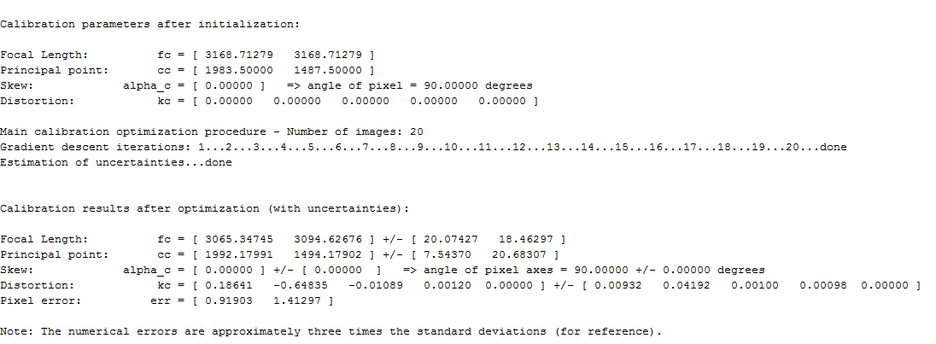

5. Reprojection error



One of images:



6. The extrinsic



7. The extrinsic world centered



8. Recomputing the corners automatically as told in the manual didn’t give much improvement in the error. Perhaps the reason is that I use the images from my cellphone with resolution of 3968*2976 and the images in the tutorial are 640*480.



Decreasing the wintx winty area decreases the error, but the corners don’t match the corners in the actual images. And images are too large to be more precise when clicking on the corner.

9. Getting familiarized with Distortion model, obtaining 3 graphs. Apparently my phone camera has a following distortion model: (complete)

I believe it isn’t a complete circle but rather an ellipse because my cellphone has actually 2 lenses placed horizontally near one another, so that it elongates the shape of the model, while still not symmetrically. I have also went through other things explained in the tutorial.

